Amazon Simple Storage Service (Amazon S3) is storage for the Internet. You can use Amazon S3 to store and retrieve any amount of data at any time, from anywhere on the web.

S3 –Basics

* S3 is Object Storage
* S3 is can be accessed globally (i.e. It’s accessed anywhere from the world, it’s not region specific)
* S3 we need to create Buckets and Buckets can hold unlimited storage space.
* Each Bucket we upload file and we need to create folder and can upload file into it, folder cannot be uploaded directly in to Bucket.
* Each file size in S3 is from 1bytes to 1TB
* In S3 while creating Bucket we need to specify bucket name which must be unique, it’s given as “Enter DNS-Compliant bucket name” we need to define (with that we get DNS address) and in which we need specific region you want to store your bucket (but you can access it globally)

CREATING BUCKET (Steps to creating new buckets in S3)

Step1: Login to AWS console and click on services and select S3, now you’re at your Amazon S3 console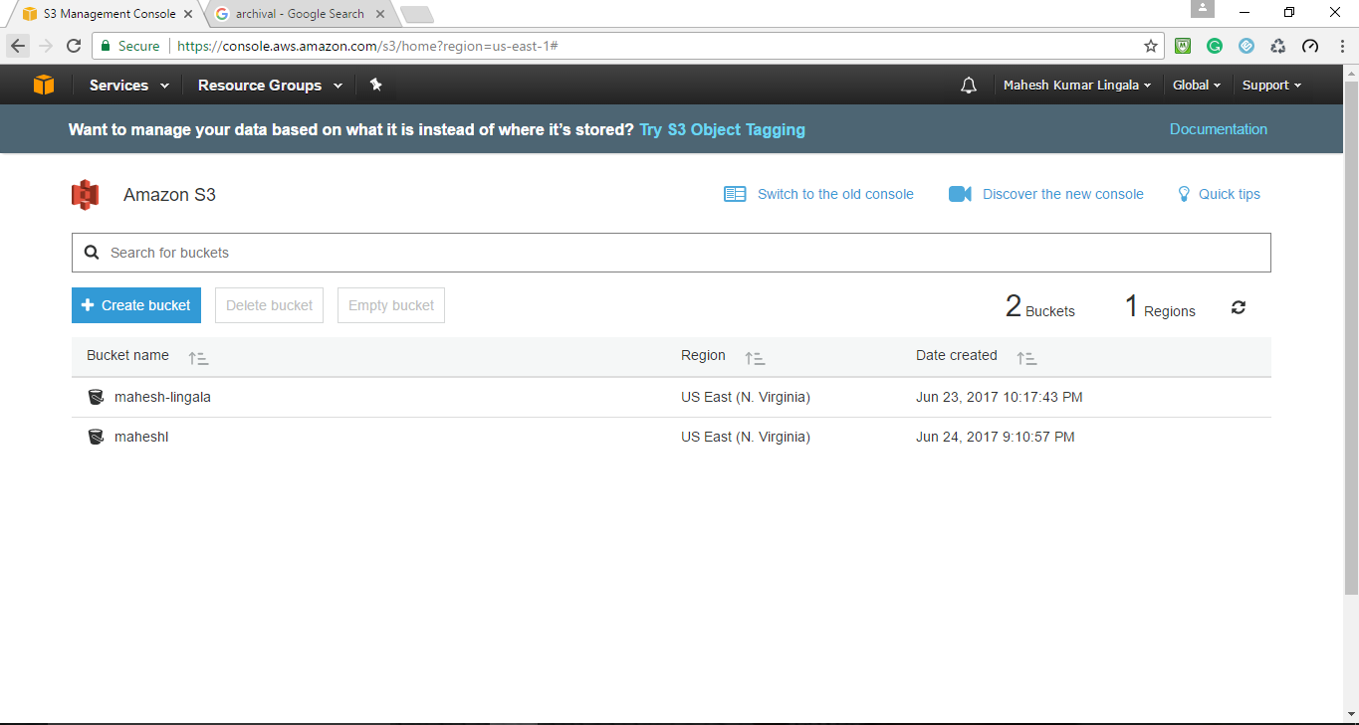

Step 2: Create New Bucket just click on ‘+create bucket’, additional tab pops on screen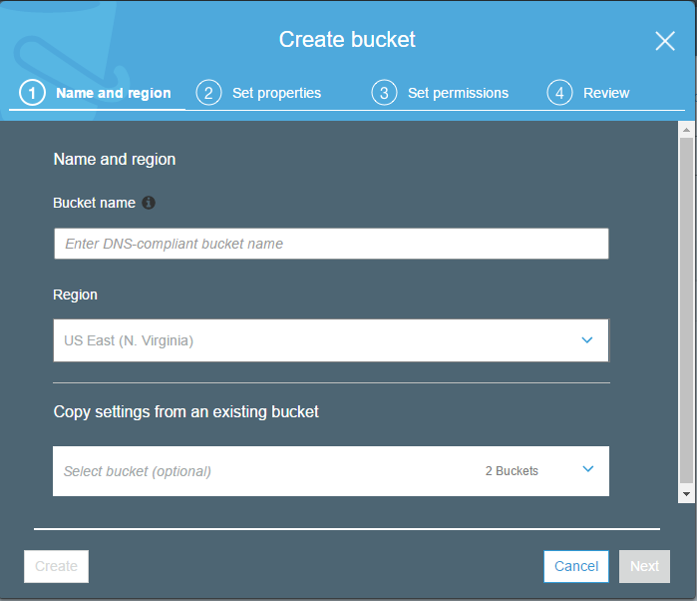

In these section (Name and region) you need specify a ‘Bucket name’ which is universal namespace (the must be unique globally). So enter you bucket name ‘Enter DNS-compliant bucket name’, next region selection is optional and the final part copy settings from an existing bucket is advanced option when you already created bucket and specified settings (object permissions) then we can use the existing settings of the bucket.

While naming bucket consider these conditions ‘Bucket name must not contain uppercase characters, Bucket name must start with a lowercase letter or number, Bucket name must be between 3 and 63 characters long.

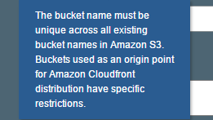

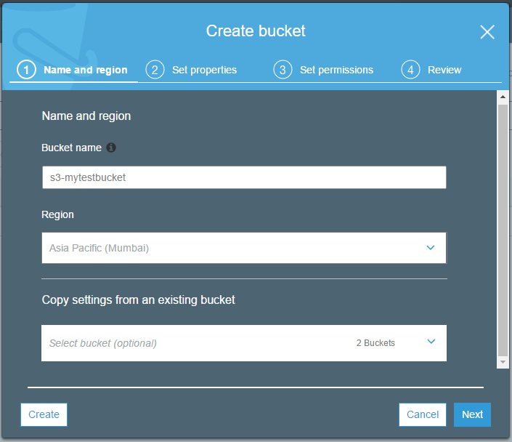

Step 3: Set properties in it we define